**Midterm**

1. Insertion sort and quick sort average case
2. Binary search average case
3. Linear homogeneous recurrence equation
4. Sorting algorithms

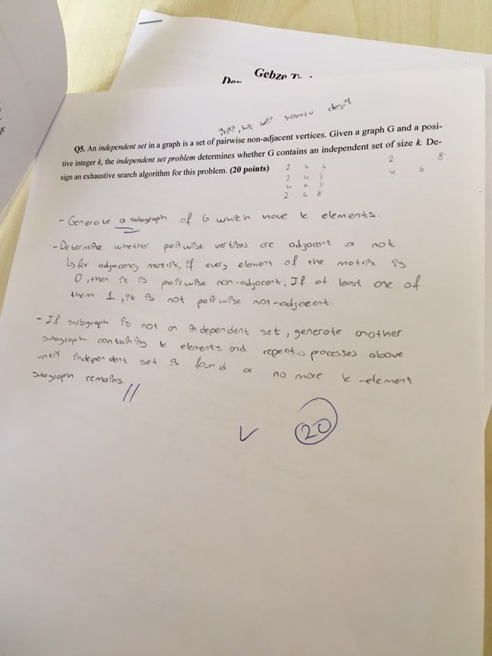

**Final**

1. Insertion sort and quick sort average case
2. Your friends are starting a security company that needs to obtain licenses for n different pieces of cryptographic software. Due to regulations, they can only obtain these licenses at the rate of at most one per month. Each license is currently selling for a price of $100. However, they are all becoming more expensive according to exponential growth curves: in particular, the cost of license j increases by a factor of rj > 1 each month, where rj is a given parameter. This means that if license j is purchased t months from now, it will cost 100×rtj . We will assume that all the price growth rates are distinct. The question is: Given that the company can only buy at most one license a month, in which order should it buy the licenses so that the total amount of money it spends is as small as possible?
3. Median of an array with quick select, show algorithm step by step with given array
4. Divide and conquer algorithm for one dimensional closest pair
5. Max square shape in matrix by dynamic programming